Login Failure Issues

Step 1 : Login to the server user facing login issue.

Step 2 : go to security tab explore logins.

Step 3 : Check login is already present in domain or not.

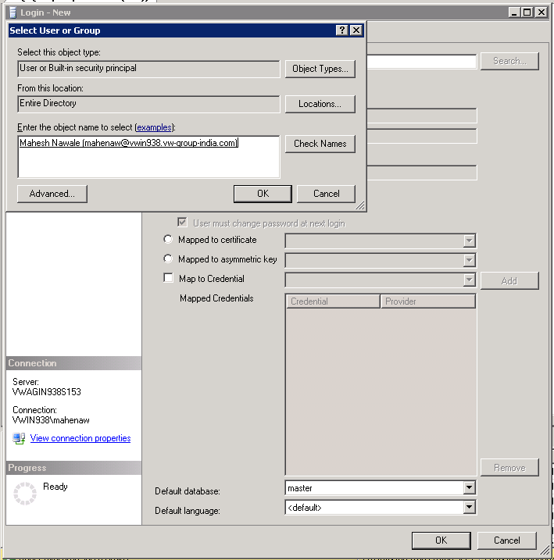

Step 4 : right click and go to properties to see the access already present to user change the rights as per requirements.

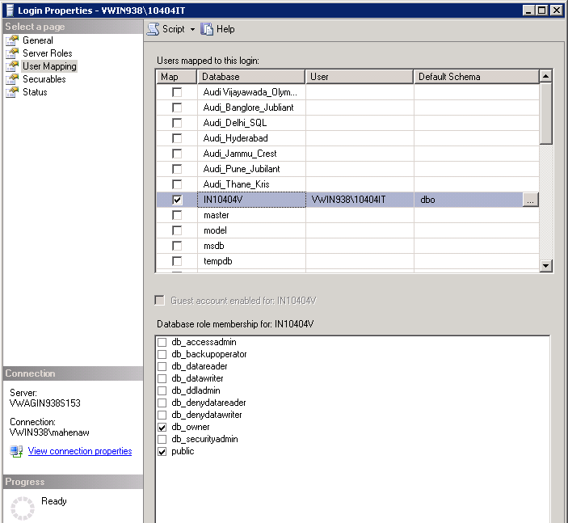

Step 6 : If user is not present in the system ask windows team to create the
Windows NT id after approval and creation of user assign the
The permission as per approval.

Step7 : After creation of Windows ID create user go to properties user
Mapping and assigns Dealers permission accordingly.

Step 8 : After confirmation transfer service now ticket from database bean to
NSC service desk.

